MED D – RxEnroll Care Downtime Procedures – Late Enrollment Penalty (LEP) Attestations and Appeals

General Information – What is a Late Enrollment Penalty (LEP)?
Identifying an LEP in PeopleSafe
Taking a Verbal Attestation
Reconsideration Requests (LEP Appeals)
Closing the Call
Resolution Time
Related Documents

Description: This document assists the CCR with MED D Late Enrollment Penalty (LEP) Attestations Appeals when the RxEnroll Care system is down due to maintenance.

General Information – What is a Late Enrollment Penalty (LEP)?
An LEP is assessed to those enrolling in a Part D plan who did not maintain creditable prescription drug coverage over a continuous period of sixty-three (63) days or longer where all the following conditions were met:

The individual:
- Was eligible to enroll in a Part D plan.
- Was not covered under any creditable prescription drug coverage as showing in MARx.
- Was not enrolled in a Part D plan as showing in MARx.
- Was not incarcerated or living out of the country when they qualified for Part D.
- Is not eligible for Low Income Subsidy.

The beneficiary will:
- Be sent an Attestation Letter including a form (Declaration of Prior Prescription Drug Coverage) if the plan does not have a record of creditable coverage.
- Have 30 calendar days to respond from the time the letter is sent.
- If the form is returned, but it is incomplete, the plan will attempt to obtain the information with a phone call.
  - If all of the information is not complete by the 30th day, a letter will be sent to the beneficiary advising that the LEP information has been submitted and an LEP will be assessed.
- The beneficiary is then given 60 days from the “reply by” date provided on the letter to dispute any potential LEP (a total of 90 days from the original Attestation Letter date).
  - If the attestation information is received after the total 90 days, then it cannot be processed by the plan and they will have to appeal directly with the Independent Review Entity, C2C Innovative Solutions. The Plan cannot assist the beneficiary in filing this appeal.

Notes:
- Low Income Subsidy eligible beneficiaries are not subject to a penalty.
- When the beneficiary is completing the attestation for other coverage the Plan does not require additional proof of coverage.
  - If the beneficiary, on their own initiative, provides proof of prior creditable prescription drug coverage, the plan sponsor will consider that information when determining whether the beneficiary had any gap in creditable coverage.

For more information, refer to:
- MED D - SilverScript Late Enrollment Penalty FAQ
- MED D - Blue MedicareRx (NEJE) - Late Enrollment Penalty (LEP) Attestation and Appeals

Top of the Document

Identifying an LEP in PeopleSafe

Perform the following:
Step | Action
1 | Is the caller the beneficiary, POA, Legal Representative or Ship Counselor?
1 | If the caller is… | Then…
1 | Beneficiary | Proceed to next step.
1 | Legal Representative | To review information for (Beneficiary’s Name), I need to verify that you are authorized to act on their behalf under the laws of the State in which the beneficiary resides. If asked to provide evidence of that authority to SilverScript/Blue MedicareRx (NEJE)> or Medicare, would you be able to do so?
1 | Legal Representative | If… | Then…
1 | Legal Representative | Yes | Proceed to next step.
1 | Legal Representative | No | Determine if the Plan has POA information on file.  Refer to: MED D - Appointed Representative Form (AOR) or Power of Attorney (POA).  If the caller is not listed under POA/Authorized Rep Details, advise the caller to fill out the Declaration of Prior Prescription Drug Coverage form that was previously mailed to the beneficiary should be mailed to:  SilverScript  PO Box 30001  Pittsburgh, PA 15222-0330  OR fax to: SilverScript Bizfax at 866-552-6205  OR  Blue MedicareRx  PO Box 30001  Pittsburgh, PA 15222-0330  OR fax to: JE Fax 866-342-7048  Blue MedicareRx (NEJE): MED D - Blue MedicareRx (NEJE) - LEP Verbal Attestation Form  CCR Process Note: The CCR must put detailed notes in PeopleSafe Med D Inquiry tab that the non-authorized party is aware of the verbal attestation process.  Proceed to Closing the Call.
1 | Ship Counselor | Refer to MED D - SHIP Counselor Calls for Part D Plans.  Proceed to next step.
2 | On the Main screen, click on the Medicare Part D Inquiry tab.  Reminder: The Medicare Part D Inquiry tab holds detail only for SilverScript and NEJE.  - For clients which Caremark does not handle/process MED D enrollment refer to the client CIF for further direction.  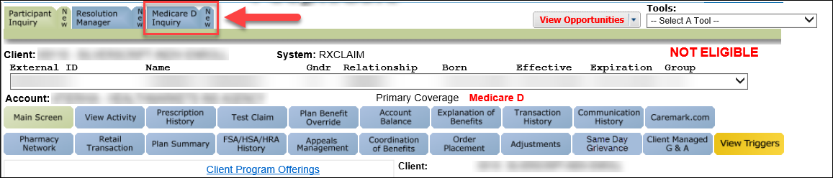
3 | Click on the Plan Details tab.  Review the Uncovered Months and Participant Penalty fields and inform the beneficiary of the LEP amount being applied to their premium.  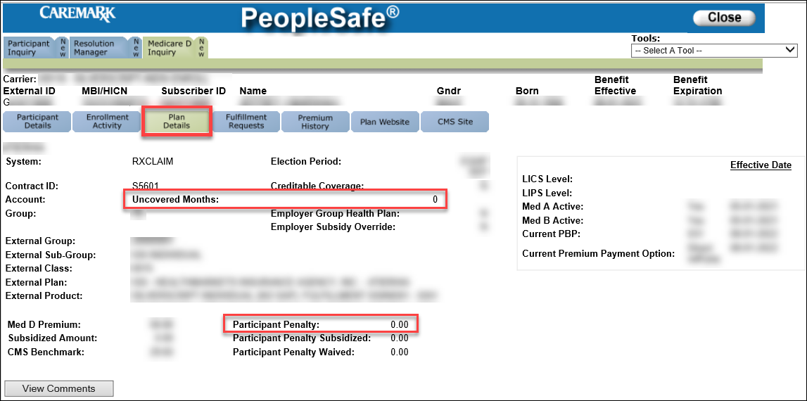
4 | Identify the reason the beneficiary (or third party) is calling.
4 | If… | Then…
4 | The caller needs to attest to coverage or questions their LEP. | Proceed to Taking a Verbal Attestation.
4 | The caller references a letter regarding their LEP. | Proceed to Review LEP Letters in OneClick.
4 | The caller refers to a reconsideration request or needs a duplicate form. | Proceed to Reconsideration Requests (LEP Appeals)
4 | The caller has no further questions. | Proceed to Closing the Call.

Top of the Document

Taking a Verbal Attestation

Perform the following:
Step | Action
1 | Is the caller the beneficiary, POA, Legal Representative or Ship Counselor?
1 | If the caller is… | Then…
1 | Beneficiary | Proceed to next step.
1 | Legal representative | To process an attestation for (Beneficiary’s Name), I need to verify that you are authorized to act on their behalf under the laws of the State in which the beneficiary resides. If asked to provide evidence of that authority to <SilverScript/Blue MedicareRx (NEJE)> or Medicare, would you be able to do so?
1 | Legal representative | If… | Then…
1 | Legal representative | Yes | Proceed to next step.
1 | Legal representative | No | Determine if the Plan has POA information on file.  Refer to: MED D - Appointed Representative Form (AOR) or Power of Attorney (POA).  If the caller is not listed under POA/Authorized Rep Details, advise the caller to fill out the Declaration of Prior Prescription Drug Coverage form that was previously mailed to the beneficiary should be mailed to:  SilverScript  PO Box 30001  Pittsburgh, PA 15222-0330  OR fax to: SilverScript Bizfax at 866-552-6205  OR  Blue MedicareRx  PO Box 30001  Pittsburgh, PA 15222-0330  OR fax to: JE Fax 866-342-7048  Blue MedicareRx (NEJE): MED D - Blue MedicareRx (NEJE) - LEP Verbal Attestation Form  CCR Process Note: The CCR must put detailed notes in PeopleSafe Med D Inquiry tab that the non-authorized party is aware of the verbal attestation process.  Proceed to Closing the Call.
1 | Ship Counselor | Refer to MED D - SHIP Counselor Calls For Part D Plans.  Proceed to next step.
2 | Review the LEP letter sent to the beneficiary (DLEP).  - Click on the Medicare D Inquiry Tab and click on the Last 12 months of Medicare Communication button to review the DLEPL letter.  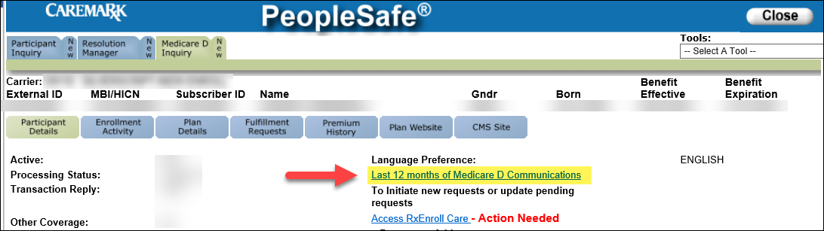  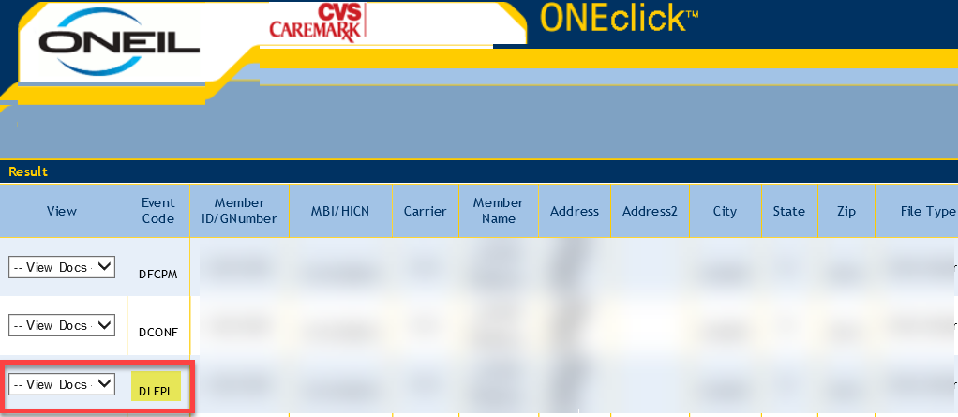  - Verify if the caller is contacting the plan within the 90 days from when the Attestation letter was sent. This is calculated by adding 60 days to the reply by date.  Example:  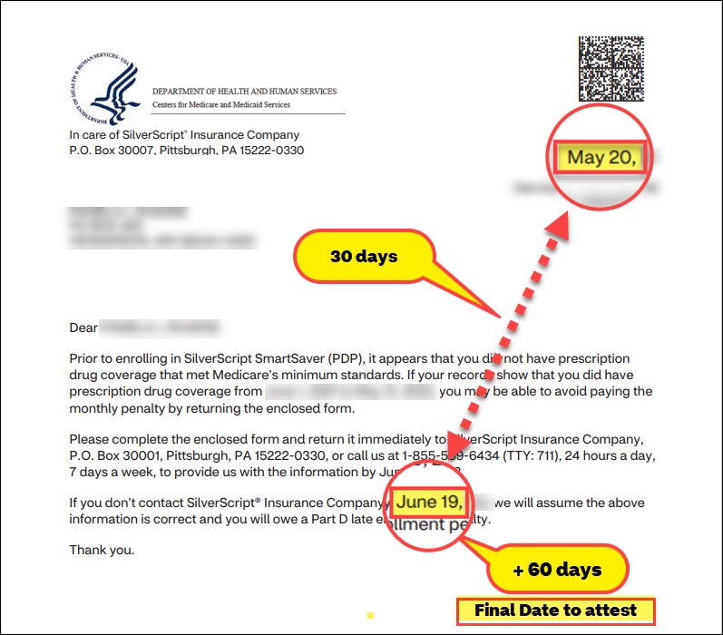  Note: Refer to the Declaration of Prior Prescription Drug Coverage form (Blue MedicareRx (NEJE): MED D - Blue MedicareRx (NEJE) - LEP Verbal Attestation Form) and review the information in the form with the caller.  Proceed to the next step.
3 | Perform the following:
3 | If the caller is… |  |  | Then…
3 | Contacting us within the 90-day window |  |  | Proceed to the next step.
3 | Contacting us after the 90-day window  OR  Beneficiary is disputing the number of uncovered months and 90 days have passed since the Attestation Letter was sent  OR  Existing LEP assessed by a prior plan |  |  | Proceed to Reconsideration Requests (LEP Appeals)
4 | Determine the correct dates needed by referencing the Attestation letter (Click on the Medicare D Inquiry Tab and click on the Last 12 months of Medicare Communication button to review the letter if not previously open from Step 2.)  Example:  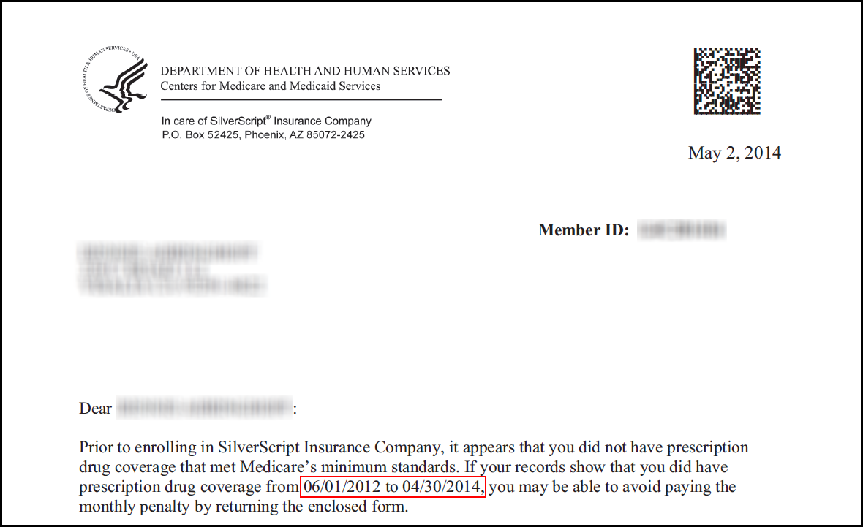
5 | Would you like help completing the form that you received with your letter, or would you prefer I submit a verbal attestation for you today?
5 | If the caller wants… | Then…
5 | To submit a verbal attestation | Perform the following:
5 | To submit a verbal attestation | Step | Action
5 | To submit a verbal attestation | 1 | Create an RM task in PeopleSafe for the following:  Task Category: Medicare D Enrollment - Enrollment  Task Type: Late Enrollment Penalty  Queue: Med D Enrollment Task  - It is required that you have creditable prescription drug coverage, that is equal to or better than the coverage that Medicare provides.  - If you did not have creditable prescription drug coverage, your premium may be higher.  - We sent you a letter to let you know that there may be a gap in your prescription drug coverage.  Document details in the task Note section for the following questions.  - Did you have creditable prescription drug coverage during the timeframe included in your letter?  - What was the start date for your coverage?  - What was the end date for your coverage?  If needed provide Legal Rep or POA (Full name, address, and phone number, and relationship to the beneficiary).  Note: Copy the note above to use for closing the call.  Proceed to next step.
5 | To submit a verbal attestation | 2 | Read this disclaimer to the caller:  - (Beneficiary’s Name) do you attest that the information that you have provided is true and correct to the best of your knowledge?  - Therefore, do I have your authorization to submit your Attestation information for review?  - Thank you, (Beneficiary’s Name), we will forward the information for review. Once we receive the decision, we (the plan) will send you a written notification regarding their decision.  Does the beneficiary attest and authorize the plan to submit the attestation for review?
5 | To submit a verbal attestation | 2 | If… |  | Then…
5 | To submit a verbal attestation | 2 | Yes |  | Proceed to next step.
5 | To submit a verbal attestation | 2 | No to either question |  | Proceed to Closing the Call to document the beneficiary does not attest to the Late Enrollment Penalty.
5 | To fill out the form | I can assist you in filling out the attestation form.  Assist the beneficiary in completing the attached form.  Once completed you can mail the form to:  SilverScript  P.O. Box 30001  Pittsburgh, PA 15222-0330  OR fax to: SilverScript Bizfax at 866-552-6205  OR  Blue MedicareRx  PO Box 30001  Pittsburgh, PA 15222-0330  OR fax to: JE Fax 866-342-7048
6 | Close the call:  - Address any benefit issues.  - Document and close the call according to existing policies and procedures, including all options discussed.  Note: Refer to the MED D - Call Documentation Including Viewing and Adding Comments in PeopleSafe Work Instruction.

Top of the Document

Reconsideration Requests (LEP Appeals)

Reconsideration requests (Appeals) for a Late Enrollment Penalty are not handled directly by the Plan. It is the responsibility of the beneficiary or the beneficiary’s POA to complete a Reconsideration packet and mail or fax the forms to the Independent Review Entity (IRE).

The current IRE is C2C Innovative Solutions. For more information on the appeals process and to obtain a Reconsideration request Form, the beneficiary can visit:

https://partdappeals.c2cinc.com// - Click on Part D Enrollees & Representatives and then Forms.

The beneficiary may also visit the following website to obtain the form, but the form must be filed with C2C Innovative Solutions:

https://www.cms.gov/Medicare/Appeals-and-Grievances/MedPrescriptDrugApplGriev/Late-Enrollment-Penalty-LEP-Appeals

Do NOT under any circumstances refer the beneficiary or a third party to Medicare.

Step | Action
1 | - If you do not agree with your Late Enrollment Penalty, you can ask for a reconsideration of this decision by submitting a Part D Late Enrollment Penalty Reconsideration Request Form.  - You will have the chance to provide proof that supports your case, like information about Creditable Prescription Drug Coverage.  - If you need help completing the form, you can contact your State Health Insurance Assistance Program (SHIP).  Note: Once a decision is made, each Part D plan that the beneficiary had ever been enrolled in, will be notified of the decision.  Proceed to the next step.
2 | You should have received a reconsideration request form with your previous LEP notice. Do you have this form, or do you need a replacement form?
2 | If… | Then…
2 | Yes | Proceed to Closing the Call.
2 | No | Proceed to the next step.
3 | From the Medicare D Inquiry Tab page, navigate to the Fulfillment Requests section.  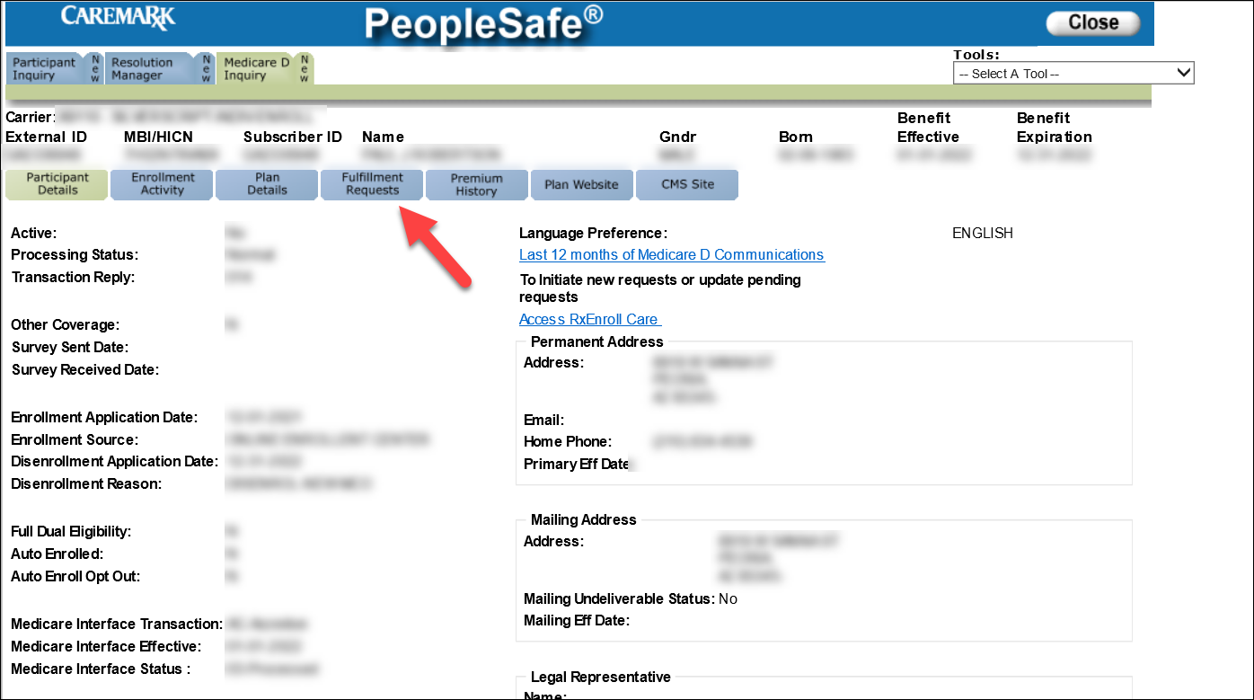  Proceed to the next step.
4 | Select LEP IRE Reconsideration from the Fulfillment List and click the Add button. Confirm the beneficiary’s address is correct and click on the Save Order button to send the form to the address listed.  Note: If the address is incorrect or the beneficiary requests a different address, click the Change Address button to change the address in the PeopleSafe Inquiry Tab.  Any changes must also be completed in RxEnroll Care and the Participant Inquiry section of PeopleSafe. Refer to Med D – Address Changes and Out of Area.  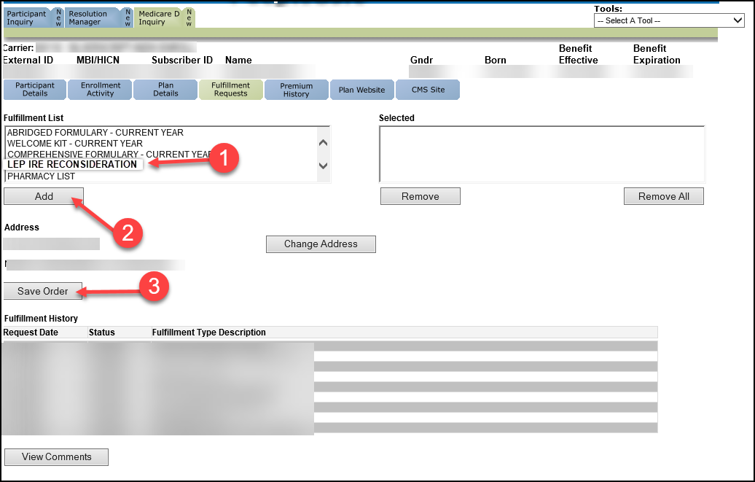
5 | You should receive the form within 7-10 business days.  Proceed to Closing the Call.

Top of the Document

Closing the Call

Perform the following:
Step | Action
1 | From the Participant Inquiry tab click on the Capture Activity button on the bottom left of the screen.
2 | In the Log Activity Notes field, use the RxEnroll or RM task notes to document the call.
3 | Click on Save Changes.
4 | - Thank you for your time today.  - As a quality measure, have I fully answered and resolved <your/the beneficiary’s> question(s) to <your/the beneficiary’s> satisfaction?
4 | If… | Then…
4 | Yes | Close the call:  - Address any benefit issues.  - Document and close the call according to existing policies and procedures, including all options discussed.  Note: Refer to the MED D - Call Documentation Including Viewing and Adding Comments in PeopleSafe Work Instruction.
4 | No | - Ask additional probing questions to attempt to resolve remaining questions or concerns.  - If unable to resolve the questions/concerns, transfer the call to a Senior Team.
5 | If needed, transfer the beneficiary to the appropriate department. (Licensed Enrollment Agent, Premium Billing, Senior Team, etc.)

Top of the Document

Resolution Time

- For Attestations: Up to 30 days depending on the information provided.

- For Appeals through C2C: Up to 90 days to receive resolution information from C2C Innovations.

Top of the Document

Related Documents

- Grievance Standard Verbiage (for use in Discussion with Beneficiary) section in MED D - Grievances Index
- Log Activity/Capture Activity Codes

Parent SOP: CALL-0048: Medicare Part D Customer Care Call Center Requirements-CVS Caremark Part D Services, L.L.C.
Abbreviations/Definitions: Abbreviations / Definitions

Top of the Document

Not to Be Reproduced or Disclosed to Others without Prior Written Approval
ELECTRONIC DATA = OFFICIAL VERSION - PAPER COPY = INFORMATIONAL ONLY

